National University of Computer and Emerging Sciences

Department of Computer Science

CS 201 – Data Structures

Final Exam (Fall 2014)

**Instructors:** Adnan Waheed and Rabia Maqsood

*December 19, 2014*

**PART – A**

|  |  |
| --- | --- |
| **Total Marks: 27** | **Time Allowed: 90 minutes** |

**Instructions:**

1. Understanding the question is part of exam. NO QUERIES WILL BE ENTERTAINED.
2. Provide answers in the given space.
3. Write neat and clean.
4. Use permanent ink pens only.
5. Multiple answers will not be marked. Clearly mention which solution you want to be checked (if you provide multiple answers). In case of ambiguity, ZERO points will be assigned to the respective question(s).

**Roll No. _________________ Section: _________**

|  |  |
| --- | --- |
| **Total Marks** | ***27*** |
| **Obtained** |  |

**GOOD LUCK ☺**

|  |  |
| --- | --- |
| **Question:** | **Marks 03x09 = 27** |

Answer the following questions briefly in the given space.

1. Consider the linked implementation of a queue. Recall that the class LinkedQueue has two pointers: front and rear. Write below that under what circumstances could the front and rear pointers be equal?
2. What does the following function do for a given linked list? Consider all cases to get full credit.

|  |
| --- |
| void guess (node* head)  {    if (head== NULL)      return;    cout<<head->data);     if(head->next != NULL)      guess (head->next->next);     cout<<head->data;  } |

1. The subtree of the root of a red-black tree is always itself a red-black tree. State your answer as TRUE or FALSE and justify your answer in both cases. No points will be given for direct answer.
2. Suppose your goal is determine whether or not a graph contains a vertex that is connected to no other vertices. Assume that there are *N* vertices and *M* edges. How long (write your answer in terms of Big-O) does the best possible algorithm take if the graph is implemented using:
   1. Adjacency lists
   2. An adjacency matrix
3. Show the result of inserting 65 into the Red-Black tree depicted below. NOTE: a node in bold is black and an italicized, underlined node is red.

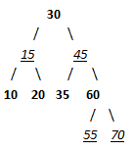

1. Apply Dijkstra's shortest paths algorithm to the graph given below, starting at vertex B.

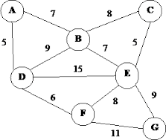

1. Demonstrate the insertion of the keys 5, 28, 19, 15, 20, 33, 12, 17, 10 into a hash table with collisions resolved by chaining. Let the table have 9 slots, and let the hash function be *h*(*k*) = *k* mod 9.
2. Given the following AVL tree, delete node 3 and re-balance the tree if required. State clearly which rotations you applied to which nodes. Draw resultant tree after every step.

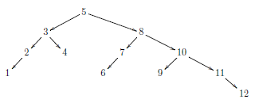

1. Six friends (a, b, c, d, e & f) decided to start combine-study preparation for their final exams but they all live at different places of the city. It creates a problem for them to decide a common place where they can get together for combine-study. They wanted to select a common place which makes all of them to travel least in a best possible way. One of them was taking CS 201 class in FAST-NUCES, (s)he promised them to find a best possible solution for everyone. Now we assume that you are the smart person who promised to find the solution. A map is given to you listing places for all the friends and approximate distance from one place to another. State the name of the algorithm which you will prefer to use and find the solution for the given map.

